Lab 13

CMOS Amplifier Design
Name: Syed Sualeh Abbas, Syed Muhammad Haider | Student ID: 10303

Objective
To get familiarized with CMOS circuits and implement CMOS common source amplifier with active load.
The CLOs, LDLs and PLOs mapped on in this lab are:
CLO | Description | LDL | PLO
CLO 1 | Investigate characteristics of basic electronic devices and their application in development of electronic solutions. | Psy - 3 | PLO-4
CLO 2 | Perform design and validation of circuits to achieve specified output utilizing semi-conductor devices. | Psy - 4 | PLO-3
CLO 3 | Apply appropriate techniques of OrCAD PSpice software for simulating electronic circuits. | Psy - 4 | PLO-5
CLO 4 | Demonstrate ethical values by complying with instructions and practicing punctuality and integrity | Aff - 3 | PLO-8

Task 1:
Explain the construction, working, and modes of operation of a PMOS. Why NMOS is faster than PMOS?
PMOS Transistor
Construction
A PMOS transistor is fabricated on an n-type substrate (or n-well). Two p-type regions are formed which act as the source and drain. A thin layer of silicon dioxide is placed between the substrate and the metal gate. The device conducts using holes as the majority carriers.
Working
The operation depends on the gate-to-source voltage. When the gate voltage is equal to or higher than the source, the transistor remains off because no channel exists. When the gate is made sufficiently negative with respect to the source, holes are attracted to the surface and form a conductive channel. This allows current to flow from source to drain due to hole movement. Hence, PMOS turns on with a negative gate voltage.
Modes of Operation
In the cut-off region, the transistor is off and no current flows because the gate voltage is not negative enough to form a channel. In the triode (linear) region, a channel is formed and the transistor behaves like a resistor, with current increasing as the drain voltage increases. In the saturation region, the channel is pinched near the drain and the current becomes almost constant.
Why NMOS is Faster than PMOS
NMOS is faster because it uses electrons as charge carriers, while PMOS uses holes. Electrons have much higher mobility than holes, which means they can move more quickly through the channel. As a result, NMOS devices can switch faster and provide higher current for the same size, making them more efficient in digital circuits.

Introduction to CMOS Circuits
CMOS technology is the dominant fabrication technology used for electronic systems including computers, smart-phones, TVs and other household appliances. CMOS is short for Complementary Metal Oxide Semi-conductor and it is a technology used for fabricating integrated circuits using both PMOS and NMOS transistors. The combination of PMOS and NMOS makes it easy to design circuits at scaled-downed size. CMOS circuits are the most widely used IC technology for both analog and digital as well as combined analog and digital (or mixed-signal) applications. Figure 1 shows CMOS device structure where 2 transistor types are combined in one structure.
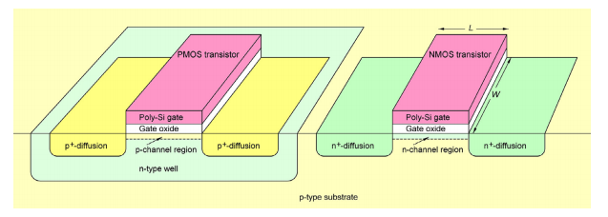
Figure 1: CMOS device structure

CMOS Amplifier
As the name implies, a MOS based amplifier that utilizes both; n-channel and p-channel MOSFETs is known as CMOS amplifier. Common Source (CS) configuration of single stage MOSFET amplifier can offer substantial voltage gain in combination with large input impedance. CMOS implementation of common-source MOS amplifiers is used in integrated circuits for amplification.

Figure 2 represents a basic CS amplifier circuit with resistive load R_{D}. We have implemented the following circuits of common-source amplifier in previous labs:
- Common-source amplifier with resistive load R_{D} and voltage-divider bias
- Common-source amplifier with diode load (R_{D} replaced by diode-connected NMOS)
- Common-source amplifier with triode load (R_{D} replaced by PMOS operating in triode region as resistor)
- Common-source amplifier (with resistive load R_{D}) biased by MOS constant-current source
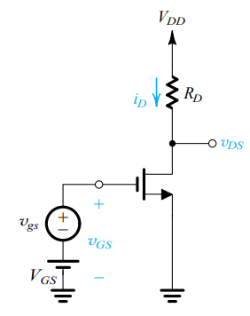
Figure 2: CS amplifier with resistive load and fixed bias with amplifier gain Av=-gm(R_{D}||r_{o})
CS amplifier with resistive loads provide limited gain as the gain of amplifier is dependent on R_{D} for given DC bias operating conditions. Increasing R_{D} can push the MOS amplifier from saturation to triode region. Moreover, in integrated circuit design, a resistor normally takes up more Silicon area than transistors. The triode load requires precise gate voltage at load MOS and CS amplifier with diode connected MOS load requires large difference in aspect ratio to achieve amplifier gain.
In this lab, we are going to replace the MOS load in CS amplifier by a constant current-source (implemented by MOSFETs). Such a configuration is called MOS common-source amplifier with Active Load or Current-Source Load.

MOS Common-Source Amplifier with Current-Source Load
The circuit shown in Figure 3(a) represents a CS amplifier circuit with current-source load. A practical current source can be replaced by constant-current source with a resistance in parallel as shown in Figure 3 (b).
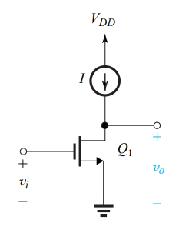  - General representation of CS amplifier with current source load | 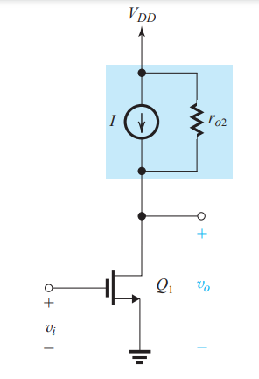  - Practical current source model as active load
Figure 3: CS amplifier with active load (current source)

Small Signal Analysis of Common-Source Amplifier with Current-Source Load
The resistance of current-source is offered to the CS amplifier MOSFET in place of resistive load R_{D}. In small signal analysis, the DC current source will be replaced by open-circuit and source resistance will be in parallel to the MOS output resistance as shown in Figure 4 which is the small-signal model of CS amplifier circuit with active load of Figure 3(b).
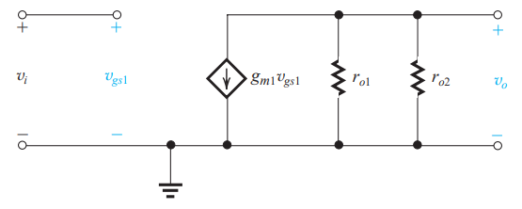
Figure 4: Small-signal model of CS amplifier with active load
In comparison to the load resistor R_{D,} the resistance of current-source is quite large. The gain of common-source amplifier with current-source load can be written as;
This is called intrinsic gain of the amplifier.

Current Source Circuit by p-channel MOSFETs
The constant-current source and current mirror circuits implemented in last lab using NMOS transistors can be implemented using PMOS transistors. Figure 5 shows implementation of a current-source circuit using PMOS. Here again, the drain and gate terminals of Q1 are tied together that keep the MOS in saturation region and resistance R is used to establish reference current. This current is mirrored by other PMOS Q2 whose grate terminal is tied to the gate of MOS Q1. Note that for PMOS circuits, source terminal is connected to the positive supply V_{DD.}
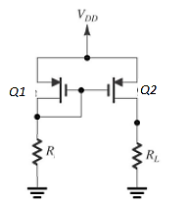
Figure 5: PMOS current mirror circuit

Task 2: To investigate the output resistance of p-channel MOS due to channel length modulation through characteristic curve
- Add a PMOS model in PSpice using MbreakP3. Edit the model to state the following given specifications of model:
- Threshold voltage: -1V
- Process trans-conductance: 0.02m A/V²
- Length: 0.25 um
- Width: 6.25 um
- Channel-length modulation coefficient: 0.01 V⁻¹
For your reference, following is the reference model code
.model MOS1 PMOS VTO= -1, KP=0.02m W=6.25u L=0.25u

- To obtain its characteristic curve, sweep the drain to source voltage from -10V to 0V for different values of gate to source voltage (-1, -2, -3 V). Measure current from source to drain.
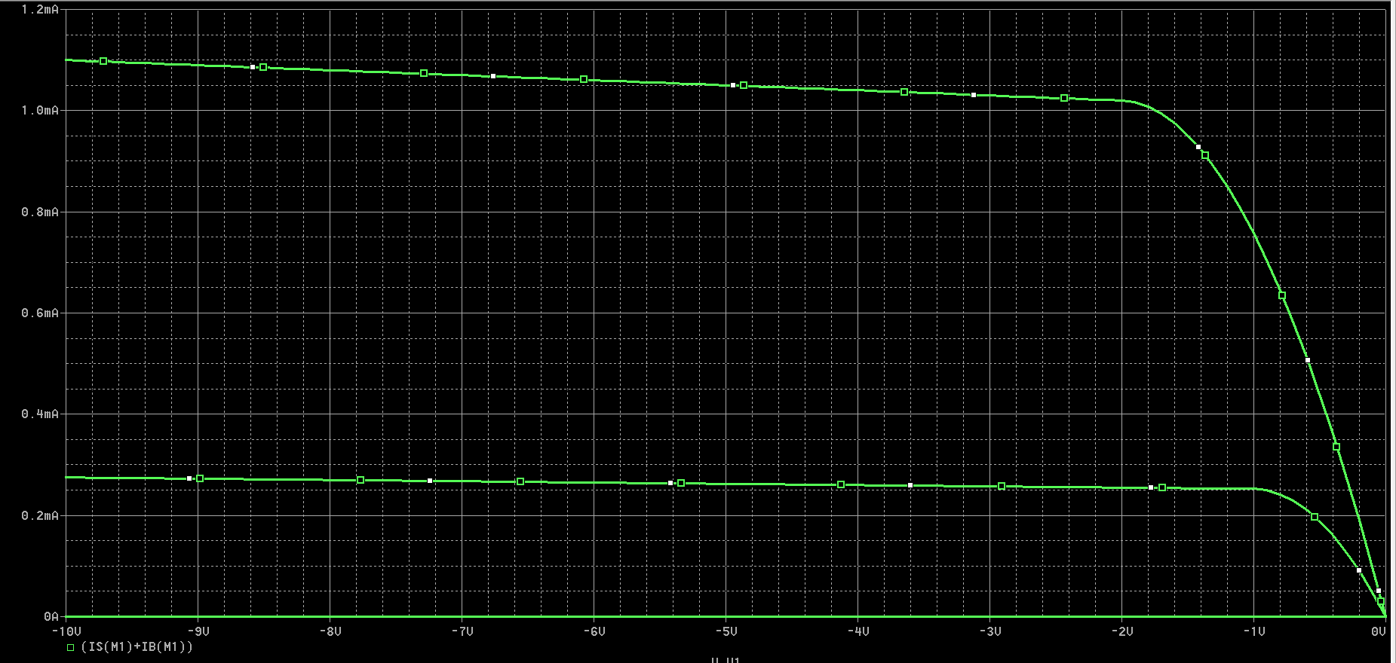

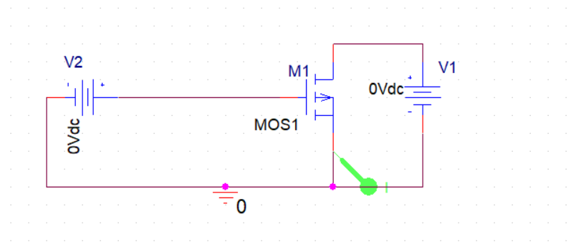
For -3v:
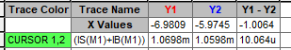
For -2v:
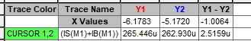
- For each of the obtained curves, find the value of output resistance r_{o} in saturation region using the formula given below. Complete Table 1.
- This output resistance can be estimated by channel-length modulation coefficient. Estimate the output resistance using value of drain current (in middle of saturation region) and specified channel-length modulation coefficient.

Table 1: Output resistance of MOSFET with channel-length modulation incorporated
Gate-to-Source Voltage V_{GS} | Output Resistance: r_{o} | Estimated Output Resistance : r_{o}
-2V | 1V /2.515uA=398K | 1 / 0.01 x 0.00025 = 400K
-3 V | -1V/-10uA= 100k | 1/ 0.01 x 0.001 = 100K

Task 3: To design PMOS current-source for given reference current
- For implementing the circuit shown in Figure 5, use the PMOS model created in Task 2 for Q1 and Q2.
- To design the current-source for obtaining 540uA current at output, find the value of resistance R. V_{DD} =10V. You can use the following equations for PMOS;
$$0.54mA=\frac{1}{2}\left(0.02 . 25\right){\left(Vgs+1\right)}^{2}$$
$$0.54=0.25{\left(Vgs+1\right)}^{2}$$
$$Vgs=-2.47V$$
So,
$$R=\frac{Vg}{Iref}=\frac{7.53V}{540uA}=13.94k$$
- Simulate the above circuit to verify your design. Connect a 7k Ohms resistor at output.

Table 1: PMOS Current Source
Calculated Value of R | 13.94k
Simulated Reference Current | 541.0uA
Simulated Output Current | 560.1 uA

- Add captures of the implemented circuit and result.
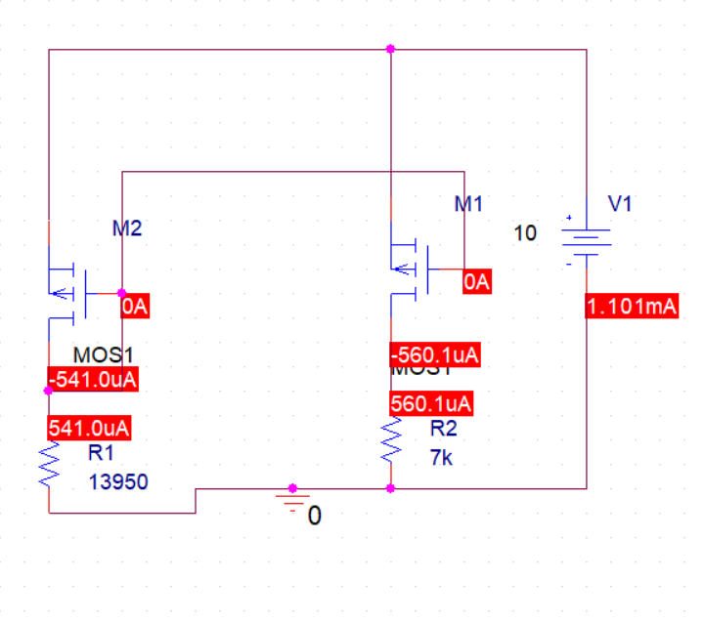
- Compare the output and reference current. If output current is different from the reference currents, what is the possible reason of any discrepancies in the results?
The output current is very close to the reference current, but not exactly the same. Ideally they should match, but small differences are normal.
This happens mainly due to non-ideal effects in MOSFETs, like channel length modulation, which makes current depend slightly on voltage. The output current (≈560 μA) is slightly higher than the reference current (≈541 μA), which is expected in practical circuits. In theory, the PMOS saturation current is assumed constant, but in simulation the model includes a parameter (λ ≈ 0.01 V⁻¹) that makes the drain current increase slightly with |VDS|. Since the two transistors do not have exactly the same VDS, their currents don’t match perfectly.

Common-Source Amplifier Circuit with Current-Source Load and Current-Source Biasing
The circuit shown in Figure 6 is CS amplifier loaded with PMOS current source. This current source is made of basic PMOS current mirror (with M4 and M5). The output impedance for the PMOS current mirror is r0 of M5 (r_{0M5}) which serves as a load in small signal equivalent circuit for gain calculations.
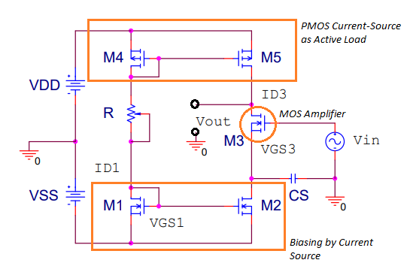
Figure 6: CMOS CS amplifier (CS amplifier with PMOS current-source with current-source biasing)

The gain of the CS amplifier with active load becomes:
The pair of M1 and M2 is used for biasing of amplifier transistor M3. The value of R has to be adjusted to establish reference current for current-source load and biasing.

Task 4: To implement common-source amplifier with PMOS current-source load
- Implement the CS amplifier circuit shown in Figure 6. Implement the current-source load using PMOS models used in previous tasks for M4 and M5. The NMOS transistors (M1 and M2) used for biasing and the amplifier MOS (M3) have following specifications:
- Threshold voltage: 1V
- Process trans-conductance: 0.8m A/V²
- Length: 1 um
- Width: 1 um
- Channel-length modulation coefficient: 0.01 V⁻¹
- The value of R selected to be 10kΩ. Vss = V_{DD}=5V.

Task 5: To investigate the characteristics of common-source amplifier with PMOS current-source load
- Perform DC analysis (through simulation) to obtain the values listed in Table 2.
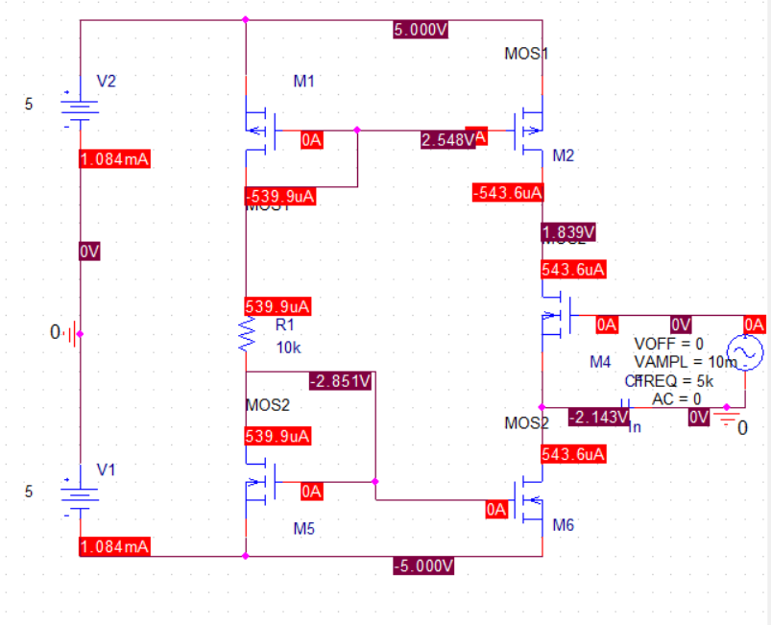
- Apply AC sinusoid input of 10mV amplitude 5 kHz at input of the amplifier. Measure unloaded output voltage of amplifier (to simulate open circuit at amplifier output terminals, we connect larges resistance 100meg Ω in PSpice). Also, connect another coupling capacitor of 10uF with to measure output.
FOR 10K
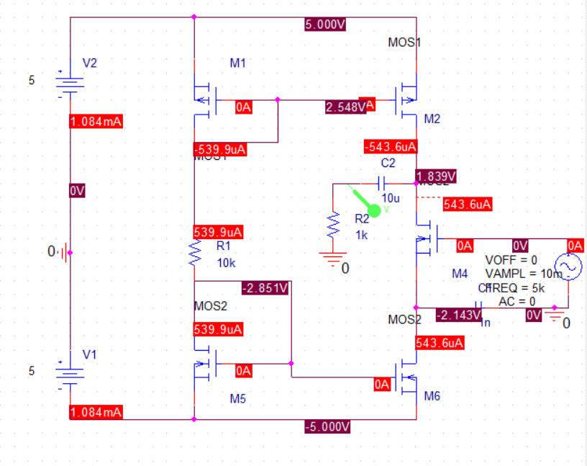
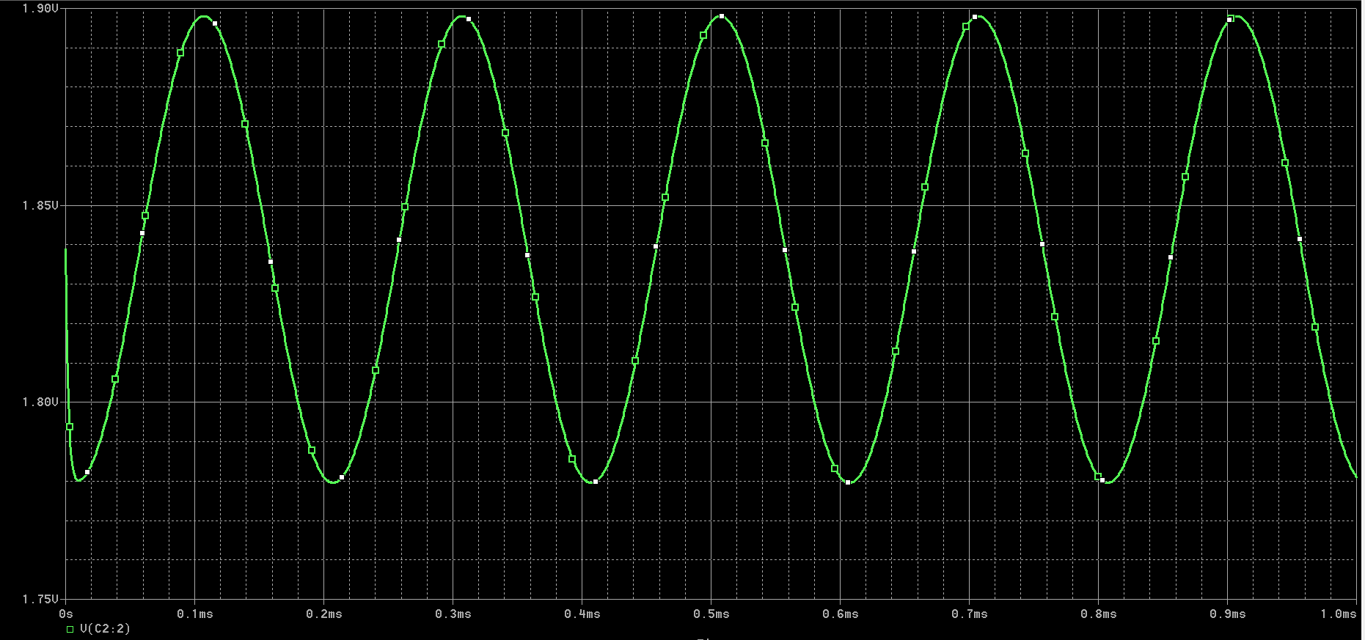

FOR 100K:
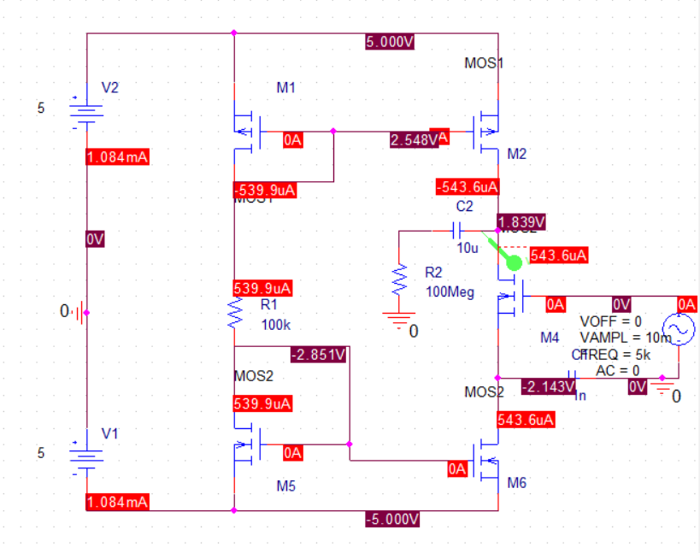
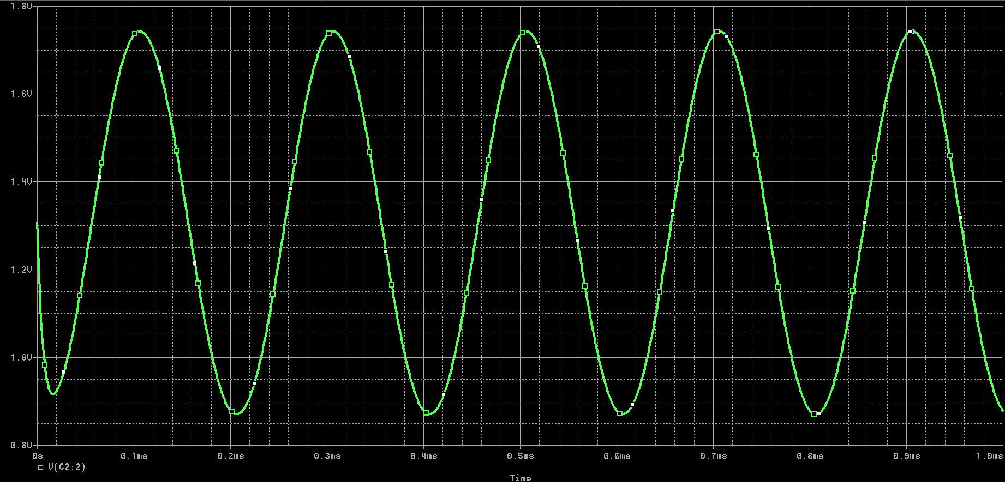
- Now, change the resistance used to set reference current from 10kΩ to 100kΩ. Measure the reference current and drain current of MOS amplifier now. What changes do you observe in gain of amplifier?
The gain is increase by about 8 times. No phase shift is observed in the signal.
- Using the formula for intrinsic gain of amplifier, try to relate the gain with drain current by using the expressions for r_{o} in terms of drain current and g_{m}=$\sqrt{2I_{D}Kn'(\frac{W}{L})}$ (note that this formula depends on MOS gerometry and drain current.
Even though a higher drain current makes the transistor stronger (higher gm), it lowers the output resistance. Because the resistance drops faster than the transconductance grows, the gain actually increases as the drain current decreases. This explains why your simulation with R = 100K Ohm (lower current) yielded a much higher gain than with 10k Ohm.

- Explain why the amplifier is called CMOS amplifier? Why do you think this configuration is preferred in IC design?
The "CMOS" in CMOS amplifier stands for Complementary Metal-Oxide-Semiconductor. It is called this because the circuit utilizes both NMOS (n-channel) and PMOS (p-channel) transistors working together "complementarily." In this specific configuration: An NMOS transistor (M3) acts as the driver/amplifier. A PMOS transistor (M5) acts as the active load (the current source).

WHY PREFRED IN ICs?

High Gain in Small Area: In a traditional circuit, you would need a very large physical resistor to get high gain. In an IC, resistors take up massive amounts of space. A PMOS transistor (active load) provides very high output resistance (Ro) while taking up a tiny fraction of the silicon area.
High Output Swing: CMOS configurations allow the output voltage to swing closer to the supply rails (Vdd and Vss), maximizing the signal range.
Power Efficiency: Because the active load behaves like a constant current source, the circuit provides stable biasing and high gain without wasting excessive power compared to passive resistive loads.

Table 2: CMOS CS amplifier parameters
Parameters | Values
Drain Current M3: I_{D} | 543.6uA
Drain Voltage M3: V_{D} | -2.143V
Source Voltage M3: V_{S} | 1.893
Drain-to-Source Voltage M3: V_{DS} | 3.979
Gate-to-Source Voltage M3: V_{GS} | 1.839
Trans-conductance M3: =$\sqrt{2I_{D}Kn'(\frac{W}{L})}$ | 343us
Output Resistance M3: r_{o}$=\frac{1}{λI_{D}}$ | 184k
Output Resistance of Load M5: r_{o5} | 185.2k
Calculated Gain: Av= -g_{m}(r_{o5} || r_{o}) | -31.65
Mode of Operation of M3 | saturation
Measured Gain: Av | -11.83

Post Lab Task

Task 6: To explore IC Fabrication: From Sand to Chip
- Explain the fabrication of integrated-circuit chips from Sand (Silicon) and provide a concise summary (no more than 200 words) about it.
The fabrication of IC chips begins by refining sand into ultra-pure silicon. This silicon is grown into an ingot and sliced into thin wafers. Using a process called photolithography, engineers use UV light to transfer complex circuit patterns onto the wafer. Through etching and doping, millions of tiny transistors are formed within the silicon structure. Microscopic metal layers are then deposited to interconnect these components, creating a functional circuit.
Because even a speck of dust can ruin a chip, this work happens in ultra-clean rooms. Once the wafer is finished, it is cut into individual squares called "dies." Each working die is placed in a protective package with metal pins, which allow it to be soldered onto a circuit board. This transformation turns raw earth into the powerful microchips that run our phones, computers, and cars.

Assessment Rubric
Lab 13
CMOS Amplifier Design
Name: | Student ID:

Points Distribution
56
Task No. | LR2  Simulation  32 | LR 4  Data Collection  20 | LR 5  Plots  12 | LR 6  Calculation  16 | LR 10  Analysis  16
Task 1 | - | - | - | - | /4
Task 2 | /8 | /4 | /4 | /4 | -
Task 3 | /8 | /4 | - | /4 | /4
Task 4 | /12 | - | - | - | -
Task 5 | /4 | /12 | /8 | /8 | /4
Task 6 | - | - | - | - | /4
 | 32 | 20 | 12 | 16 | 16
 | CLO1 | CLO1 | CLO2 | CLO3 | CLO1

Affective Domain Rubric |  | Points | CLO Mapped
AR 4 | Report Submission | 4 | CLO 4

CLO – (LDL) | Total Points | Points Obtained
1 – (Psy-3) | 68
2 – (Psy-4) | 12
3 – (Psy-4) | 16
4 – (Aff-3) | 4
Total | 100

For description of different levels of the mapped rubrics, please refer the provided Lab Evaluation Assessment Rubrics and Affective Domain Assessment Rubrics.

